**Name:** Swagat Panda

**ID:** 2017B5A30983P

**Lab VI**

**Study and design of active filters using LM741**

Objective

a)      Design a Band Pass Filter using OPAMP (IC-741).

b)      Show the frequency response with 3dB frequency and compare your simulated value with theoretical value.

Apparatus Required

* LM 741
* Voltage Supply of 15 V each
* A 100mV voltage source for the input
* Resistors of the following values (in kilo Ohms) – 2.2, 3.9, 5.6, 10
* Capacitors of the following values (in uF) – 0.1

Theory - Sallen-Key Bandpass Filter

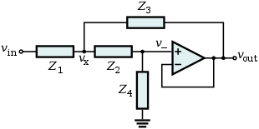 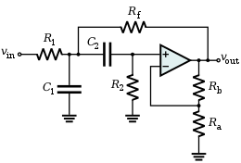

The Sallen-Key Topology Sallen-Key Band Pass Filter

A VCVS filter uses a voltage amplifier with practically infinite input impedance and zero output impedance, and can be used to implement a 2-pole bandpass filter.

The VCVS filter allows high Q factor and passband gain without the use of inductors. It also has the advantage of independence, i.e., VCVS filters can be cascaded without the stages affecting each other’s tuning. A Sallen–Key filter is a variation on a VCVS filter that uses a unity-voltage-gain amplifier (i.e., a pure buffer amplifier).

Procedure

* Connect the circuit as per the given values
* Simulate

1. Band Pass Filter

Schematic

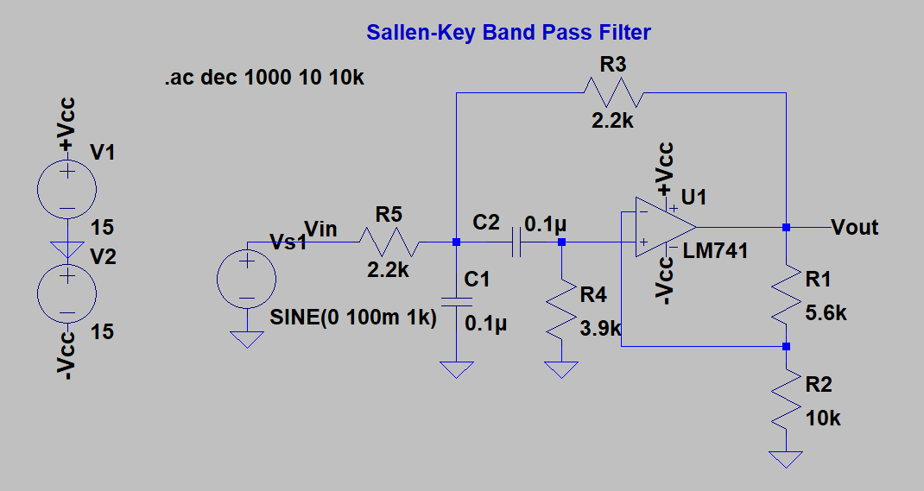

Frequency Response Plot – Bandpass Frequency

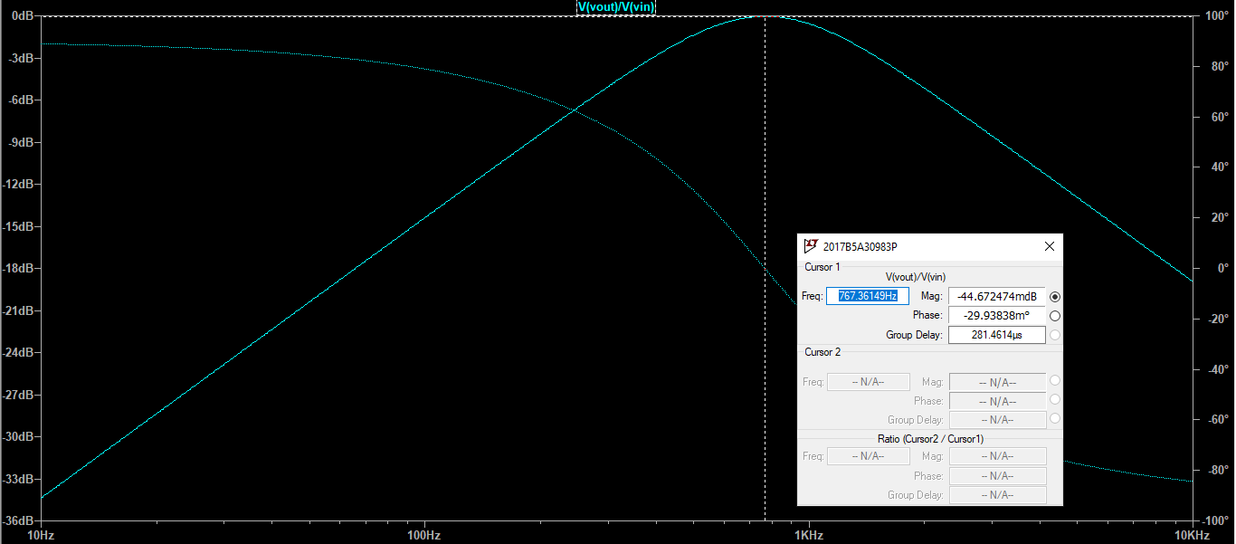

Frequency Response Plot – fl and fh

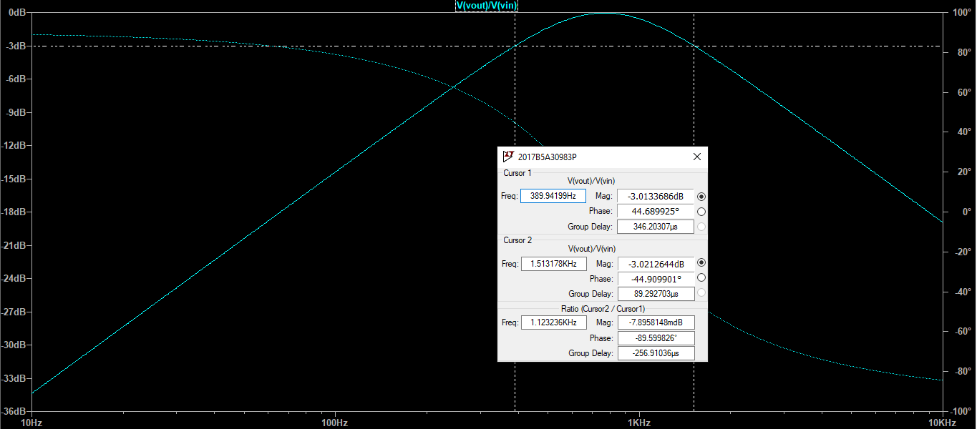

Results

|  |  |  |
| --- | --- | --- |
| **Type of filter** | **Theoretical value of 3dB/cutoff frequency** | **Simulated value of 3dB/corner frequency** |
| Band-pass filter | $$f_{0}=\frac{1}{2π\sqrt{\frac{R_{3}R_{4}{R_{5}C}_{1}C_{2}}{R_{3}+R_{5}}}}=\frac{1}{2π×2071.23×0.1μ}=768.407 Hz$$ | 767.361 Hz |
|  | $$Q=0.677315$$ | Q = 0.68327 |

Fl = 389.94199Hz

Fh = 1.513178KHz

Conclusions

* The simulated values are in agreement with the theoretical values as expected.